**Mobile Programming**

**For Learning visit => https://ionicframework.com/docs/components**

1. To install ionic and its development environment and run the

basic default application to understand the files used.

STEPS:

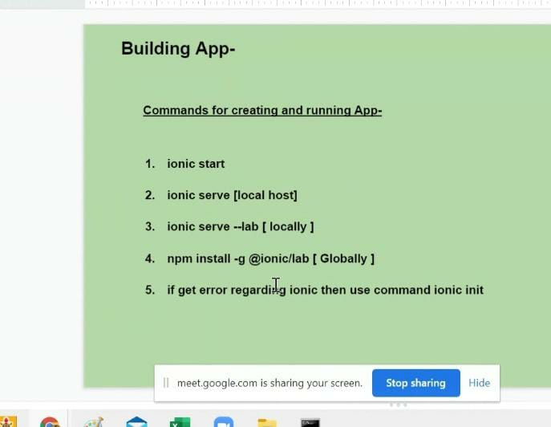

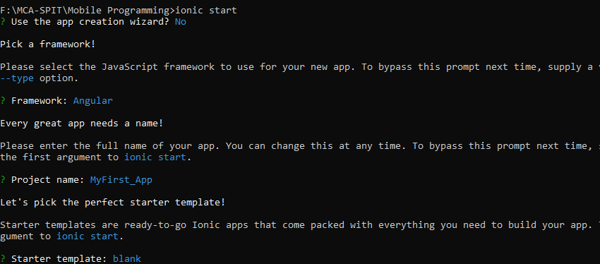





**F:\MCA-SPIT\Mobile Programming\MyApp>npm install -g semver**



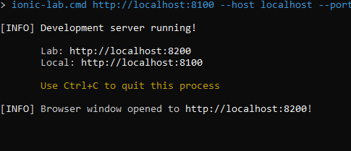

**For creating new page in exisiting folder => ionic g page page_name**

2) To create an Museum app using basic UI components and SASS

[Syntactically awesome style-sheet]

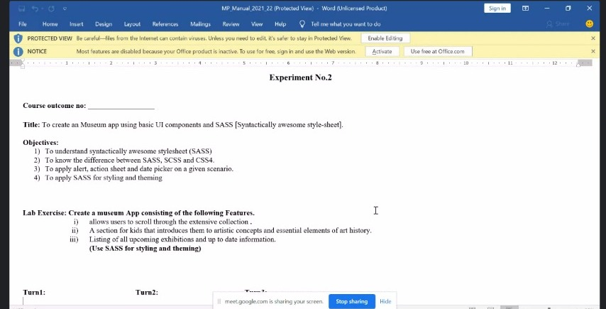

STEPS:=>



**? Framework: Angular**

**? Starter template: tabs**

